Refugees, Displacement, Statelessness
HIST 492 ~ MWF 1:30-2:20pm ~ UNIV 319

Professor Klein-Pejšová (PAY-shova)
Email: rkleinpe@purdue.edu
Office: University Hall 022
Office hours: W 2-4pm, or by appointment

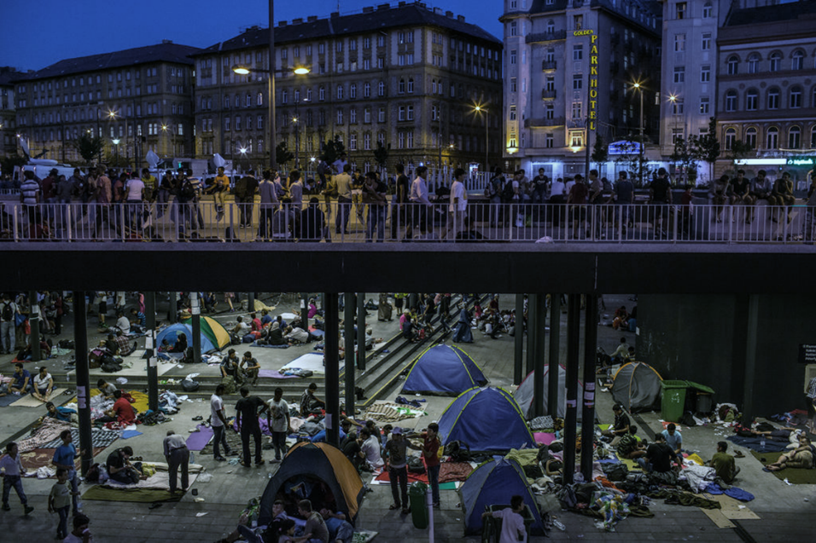
“Budapest’s Keleti train station has become a de facto refugee camp”
Anemona Hortocollis, “Traveling in Europe’s River of Migrants,” NYT, 2 September 2015

The expansion of Syrian refugee movement across the Mediterranean into Europe during the summer of 2015 drew the world’s attention anew to problems of mass displacement. The United Nations High Commission on Refugees (UNHCR) estimates that 65.3 million people worldwide were living in a condition of displacement in 2015, surpassing numbers we saw at the end of World War II. With prospects for return bleak, this is not a situation that is going away anytime soon. This course examines the experience of refugees and displaced persons from the first mass civilian displacement during World War I through the present, centering on interactions between refugees, policy makers, and local populations against an international backdrop. We will pay special attention to the intersection of the refugee experience with human rights developments. We will make use of primary sources and secondary literature, fiction, memoirs, film and other media in the course of our examination. Counts toward the Human Rights minor.
Required Texts:
• Peter Gatrell, The Making of the Modern Refugee (Oxford, 2013, paperback edition 2015)
• Michael R. Marrus, The Unwanted (Temple UP, 2002 edition)
• Zolberg, Suhrke, and Aguayo, Escape from Violence (Oxford, 1989)
• e-resources: Available on Blackboard. Marked with an asterisk [*] on the syllabus.

Analytical Strategy:
As we study this topic, the following themes will aid our analysis of the refugee experience across the range of historical cases we explore (drawn from Peter Gatrell’s approach in The Making of the Modern Refugee):
• causes for refugeedom;
• approximate numbers of people affected, how those numbers are derived;
• conditions of sojourn, policy toward refugees (domestic & international);
• protections offered for refugees;
• sources and nature of humanitarian aid;
• relative importance of diasporic ties;
• conditions of repatriation;
• refugee nationality/ citizenship/ statelessness;
• representations of refugees;
• refugee agency/ refugee voices;
• commemoration; and
• relationship of the refugee experience to human rights developments.

Attendance Policy:
Attendance at all class sessions is mandatory. We are a small seminar. Arrive on time. An attendance sheet will be passed around to sign at the beginning of class. More than four (4) absences will result in a grade penalty (1/2 of a letter grade) for each subsequent unexcused absence. Unexcused means undocumented by a doctor's note, or other valid form of documentation. If there is an occasion where you must leave early, notify me before class starts and sit near an exit. Be courteous. Do not disrupt the professor or your fellow students. Put away all electronic devices unless otherwise specified. Be prepared to participate.

Course Requirements:
- Reaction Logs and Participation (RL) (50% of course grade): You will write reaction logs (1-2 pages max) answering the question of the week, based on the readings. Reaction logs are due at the beginning of class on Fridays, typed, and in hard copy. You will receive a grade for each entry. The final cumulative grade will be posted on blackboard.

- Book Review and presentation (25% of course grade): You will write a 5-page book review of a book chosen from a prepared list. The book review should include identification of the author and the author's credentials, discussion of the book's argument (or main message), the author's most important observations and conclusions, discussion of sources (or background for novels), and what is new and/or distinctive about the method, argument, style, conclusions. The book review will be due on Monday, March 6th, with presentations March 6th & 8th.

- Final exam (25% of course grade): You will write a 5-page take-home one question final exam due on Friday, April 21st. We will discuss your responses to the question during the last week of class.

*Written work for this course must adhere to the following format: double-spaced, one-inch margins, in 12 point Times New Roman font, paginated, proofread, and including Chicago Style footnotes for the book review and research paper. Assignments are due at the beginning of class. No email attachments. Late papers will be penalized by 5 points for each day late.

• Cheating / Plagiarism: Plagiarism refers to the reproduction of another's words or ideas without proper attribution. Cheating, plagiarism, and other forms of academic dishonesty are serious offenses, and will result in a failing grade and notification of the Dean of Students Office. Don't do it.
• Course evaluations: During the 15th week of classes, you will receive an official email from evaluation administrators with a link to the evaluation site. You will have two weeks to complete the evaluation. I do not see your evaluation until after grades are submitted.
• Disclaimer: In the event of a major campus emergency, the above requirements, deadlines and grading policies are subject to changes that may be required by a revised semester calendar. Any such changes in this course will be posted on Blackboard once the course resumes or can be obtained by contacting the professor via email.
*Email etiquette: Outside of class or office hours, communicate with your professor by email. State the reason for your email in the subject line (ex: “question about essay”). Include a full salutation (ex: “Dear Professor”), and closing with your full name (ex: “Sincerely, Eleanor Roosevelt”). Use full sentences, correct grammar, and punctuation. If you fail to follow this etiquette, I will not respond to your email. I will usually respond to your emails within 24 hours, with the exception of weekends.

***
Schedule of Classes
Week 1: Who is a Refugee?
M, 1/9: Introduction, Course Overview, Approaches, Questions
• 1951 Convention on Refugees* - esp. Article 1.A.2, and Article 33
W, 1/11: Zolberg, et al, ch.1, pp. 3-18.
F, 1/13: Zolberg, et al, ch.1, pp. 18-33.
•RL#1: What do the authors mean when they use “violence” as a way to organize their definition of “refugee”? How closely does this apply to the way you have thought about refugees and the condition of being a refugee (refugeedom)?

Week 2: Migration Stories
M, 1/16: No Class – Martin Luther King, Jr. Day
W, 1/18: Nomads & Others
• Slezkine, The Jewish Century (Princeton UP, 2004), pp.4-39.*
• Who are the “Mercurians” and “Apollonians”? How have they interacted with each other? How are migration and migrants perceived (and “Others”)?
F, 1/20: MIGRATION STORIES DUE (counts as RL#2):
• prepare a story from your family’s (or your own) migration history, whether in the U.S. or international (2 pgs). Examples from Prof. Susan Gzesh’s (Pozen Center, UChicago) classes have included: “how my grandmother moved from rural Mississippi to Chicago,” “when my father came to the US from Jordan to go to graduate school and met my mother in class,” and “when my great-grandfather escaped from being drafted into the Tsar’s army.”

Week 3: The Great War and its Refugees
M, 1/23: Gatrell, pp. 17-35
W, 1/25: Marrus, pp. 51-68
F, 1/27: Gatrell, pp. 35-51
•RL#3: How were refugees from the Eastern front of war represented, and how important was that representation for galvanizing national development?

Week 4: Imperial Collapse, Upheaval, and New National States in Interwar Europe
M, 1/30: Gatrell, pp.52-81.
W, 2/1: Arendt, Origins of Totalitarianism, from ch. 9, pp. 267-290.*
F, 2/3: Dragostinova, Between Two Motherlands (Cornell UP, 2011), ch.4*
•RL#4: How was the principle of minority rights invoked to justify the exchange of minorities between Bulgaria and Greece? How did the population exchange influence relations between Bulgaria and Greece?
Week 5: Flight from Fascism
M, 2/6: Gatrell, pp.85-94.
W, 2/8: Marrus, pp. 122-158.
*Human Rights Lab TBA
F, 2/10: Atina Grossmann, “Remapping Relief and Rescue”*
•RL#5: What conditions made the sojourn of Polish Jewish refugees in Central and South Asia (Iran, India) possible during the Second World War? In what ways does Grossmann argue that this experience shifts our understanding of wartime relief and rescue?

Week 6: Blood, Ashes, Displacement, Diaspora: Postwar
M, 2/13: Gatrell, pp. 94-117.
W, 2/15: Marrus, pp. 296-345.
F, 2/17: Cohen, “The Politics of Recognition.” *
•RL#6: According to Cohen, how did the classification of Jewish Displaced Persons (DPs) as an “ideal type community of victim by western humanitarianism” affect their spectrum of postwar possibilities for rebuilding their lives?

Week 7: Jews and Palestinians Together and Apart
M, 2/20: Gatrell, pp. 118-132
W, 2/22: Gatrell, pp. 132-147.
F, 2/24: LeBor, City of Oranges, pp. 163-186.*
•RL#7: Of what benefit is an approach like LeBor’s in narrating the fraught history of Arabs and Jews in the hotly contested territory of today’s Israel? How effective is it in expressing refugee agency and refugee voices?

Week 8: South Asian Partition and Demographic Reorganization
M, 2/27: Gatrell, pp. 148-177.
W, 3/1: Zolberg, et al, pp. 126-135.
F, 3/3: Zolberg, et al, pp. 135-154.
• No RL this week – keep working on your book reviews!

Week 9: Book Review Week
M, 3/6 & W, 3/8: presentations and discussions
*Human Rights Lab TBA

Week 10: No Classes M, 3/13 through F, 3/17 - SPRING BREAK

Week 11: Revolution and Reaction in East Asia
M, 3/20: Gatrell, pp. 178-196.
W, 3/22: Zolberg, et al, pp. 155-160. China
F, 3/24: Zolberg, et al, pp. 160-179. Southeast Asia
•RL#8: How do Zolberg and his co-authors discern and address the causes and implications of refugee flows in Southeast Asia? To what extent do they implicate international factors in those refugee flows?

Week 12: Colonial Legacies and Citizenship Crisis in Africa
M, 3/27: Gatrell, 223-237.
W, 3/29: Gatrell, 237-252.
F, 3/31: Mamdani, When Victims Become Killers (Princeton UP, 2001), ch.8
•RL#9: What is the relationship between the nature of the resolution of the genocide in Rwanda and the citizenship crisis in Eastern Congo, as Mamdani explains it? By what manner of group belonging is citizenship defined in Eastern Congo?

Week 13: Conflict and Refugees in Latin & Central America
M, 4/3: Zolberg, et al, pp. 180-203. Latin America
W, 4/5: Zolberg, et al, pp.204-224. Central America
F, 4/7: Find and bring in a news article or report on current migration from Latin or Central America to the United States to share and discuss.
•RL#10: To which course theme does the news article you have chosen most directly apply? In what ways? How is migration and/or the refugees in your article represented?
Week 14: Refugee Voices
M, 4/10: Gatrell, ch.9, pp. 253-282.
W, 4/12: Gatrell, conclusion, pp. 283-296.
F, 4/14: Azoulay, “’The Family of Man’: A Visual Universal Declaration of Human Rights”*

Week 15: Current Challenges
M, 4/17: UNHCR Emergencies http://www.unhcr.org/en-us/emergencies.html
W, 4/19: UNHCR Emergencies http://www.unhcr.org/en-us/emergencies.html
F, 4/21: TAKE-HOME FINAL EXAM DUE

Week 16: GLHRC, HRP Symposium, and Concluding Discussion
*Sunday, 4/23: The Greater Lafayette Holocaust Remembrance Conference (GLHRC) – Atina Grossmann will deliver the keynote. More details to follow@ www.glhrc.org
*M, 4/24: Human Rights Program Symposium: Refugee Crises Past and Present – more details to follow. Attend instead of class on this day.
W, 4/26: In-class discussion of final exam question.

